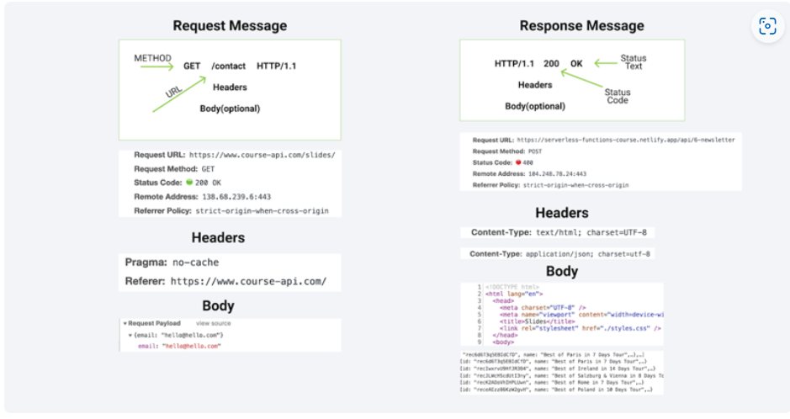

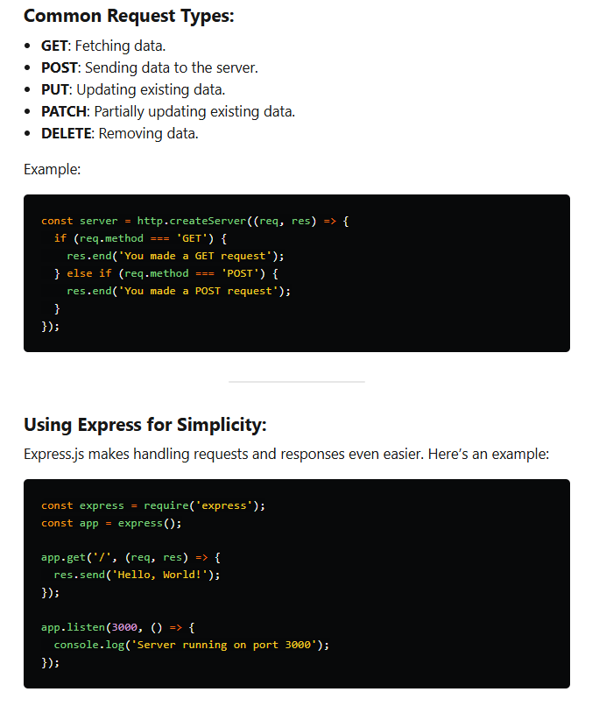

Middleware

Middleware is a function that sits in the request-response cycle of an application. It has access to the request object (req), the response object (res), and the next middleware function in the application’s request-response cycle.

**How it Works**:

1. Middleware functions are executed sequentially in the order they are defined.
2. Each middleware function has access to req, res, and the next function.
3. The next function is a callback that passes control to the next middleware function.
4. If a middleware function doesn't call next(), the request-response cycle is terminated, and the response is sent.

**Middleware Function Signature in Express.js**

The signature of a middleware function in Express.js is:

javascript

function (req, res, next) {

// Middleware logic

next(); // Pass control to the next middleware function

}

**Common Use Cases for Middleware in a Node.js Application**

1. **Logging**: Recording details about incoming requests and responses.

javascript

function logger(req, res, next) {

console.log(`${req.method} ${req.url}`);

next();

}

1. **Authentication**: Verifying user credentials before granting access to certain routes.

javascript

function authenticate(req, res, next) {

if (req.isAuthenticated()) {

return next();

}

res.redirect('/login');

}

1. **Body Parsing**: Parsing JSON or URL-encoded data from the request body.

javascript

const bodyParser = require('body-parser');

app.use(bodyParser.json());

app.use(bodyParser.urlencoded({ extended: true }));

1. **Error Handling**: Catching and handling errors that occur during request processing.

javascript

function errorHandler(err, req, res, next) {

console.error(err.stack);

res.status(500).send('Something broke!');

}

1. **Serving Static Files**: Serving static files such as HTML, CSS, and JavaScript files.

javascript

app.use(express.static('public'));

These are some of the most common use cases and examples of middleware in a Node.js application using Express.js. Middleware makes it easier to handle complex application logic by breaking it down into smaller, manageable pieces.

I hope this helps! Let me know if you have any more questions or need further clarification. 😊✨

NEXT

In an Express.js application, the next function is a crucial component of middleware functionality. Here’s why it’s important and what happens when you don't use it correctly:

**Importance of next**

1. **Middleware Chain**:
   * Middleware functions are called in a sequence. The next function is used to pass control from one middleware function to the next in the chain. Without calling next, the request processing stops, and subsequent middleware or route handlers won't be executed.
2. **Error Handling**:
   * By using next, you can pass errors to the next error-handling middleware. This helps in centralizing error handling and responding appropriately based on the type of error.
3. **Asynchronous Operations**:
   * In many cases, middleware functions perform asynchronous operations like database queries. The next function ensures that these operations complete before the control is passed to the next middleware or route handler.
4. **Modularity**:
   * Middleware functions are reusable components that perform specific tasks. Using next allows you to build a modular and maintainable codebase by separating concerns.

**Example of Using next**

Here’s a simple example of using next in an Express.js application:

javascript

const express = require('express');

const app = express();

// Middleware function to log requests

function logRequests(req, res, next) {

console.log(`${req.method} ${req.url}`);

next(); // Pass control to the next middleware or route handler

}

// Middleware function to check authentication

function checkAuth(req, res, next) {

if (req.isAuthenticated()) {

next(); // Pass control to the next middleware or route handler

} else {

res.status(401).send('Unauthorized');

}

}

// Use middleware functions

app.use(logRequests);

app.use(checkAuth);

// Route handler

app.get('/dashboard', (req, res) => {

res.send('Welcome to the dashboard!');

});

app.listen(3000, () => {

console.log('Server is running on port 3000');

});

**What Happens Without next**

If you remove next from your middleware functions or forget to call it:

* **Request Stalls**: The request will stall and eventually time out because the control never reaches the next middleware or route handler.
* **Incomplete Request Handling**: Subsequent middleware functions or route handlers will not execute, leading to incomplete request processing.
* **Error Handling Issues**: Errors that occur in one middleware function won’t be passed to the next error-handling middleware, leading to unhandled errors.

**Example Without next**

Here’s what could go wrong if you forget to use next:

javascript

const express = require('express');

const app = express();

function logRequests(req, res, next) {

console.log(`${req.method} ${req.url}`);

// next(); // Missing next() will cause the request to stall here

}

app.use(logRequests);

app.get('/dashboard', (req, res) => {

res.send('Welcome to the dashboard!');

});

app.listen(3000, () => {

console.log('Server is running on port 3000');

});

In this example, the /dashboard route will never be reached because next() is not called in the logRequests middleware, stalling the request.

**Summary**

Using next is vital for ensuring that middleware functions work correctly together, passing control from one to the next, handling errors properly, and maintaining a modular and clean codebase. Without next, your middleware chain breaks, causing incomplete request processing and potential errors.

Let me know if you have any more questions or need further clarification! 😊✨

**What is CORS?**

**CORS** (Cross-Origin Resource Sharing) is a security feature implemented by web browsers that allows or restricts resources on a web page to be requested from another domain outside the domain from which the resource originated. It is a mechanism to let servers specify who can access their resources and how.

**Why is CORS Important?**

CORS is crucial because it:

* **Enhances Security**: Prevents unauthorized access to your resources from other domains.
* **Facilitates Secure Sharing**: Allows safe sharing of resources between different domains (such as between a front-end application on one domain and an API on another).
* **Prevents Malicious Actions**: Protects against various security vulnerabilities like CSRF (Cross-Site Request Forgery).

**How CORS Works**

CORS involves two types of requests: **simple requests** and **preflight requests**.

1. **Simple Requests**:
   * Used when the request method is GET, POST, or HEAD.
   * Request headers are simple headers like Accept, Accept-Language, etc.
   * Browser checks the response headers to decide if the request is allowed.
2. **Preflight Requests**:
   * Used for other HTTP methods (PUT, DELETE, etc.) or non-simple headers.
   * Browser sends an OPTIONS request to the server with Access-Control-Request-Method and Access-Control-Request-Headers.
   * Server responds with Access-Control-Allow-Methods and Access-Control-Allow-Headers.
   * If the response is satisfactory, the actual request is sent.

**Enabling CORS in Express.js**

To enable CORS in a Node.js application using Express.js, you can use the cors middleware package.

**Installation**:

bash

npm install cors

**Usage**:

javascript

const express = require('express');

const cors = require('cors');

const app = express();

// Enable CORS for all routes

app.use(cors());

app.get('/example', (req, res) => {

res.json({ message: 'This is an example route!' });

});

app.listen(3000, () => {

console.log('Server is running on port 3000');

});

**Configuring CORS**

You can customize the CORS configuration by specifying various options:

javascript

const corsOptions = {

origin: 'http://example.com', // Allow only this origin

methods: ['GET', 'POST'], // Allow only these methods

allowedHeaders: ['Content-Type', 'Authorization'], // Allow only these headers

credentials: true, // Allow credentials

};

app.use(cors(corsOptions));

**Common Use Cases for CORS Middleware**

1. **API Access**: Allowing a front-end application on one domain to access APIs hosted on another domain.
2. **Microservices Communication**: Enabling communication between microservices hosted on different domains.
3. **Third-Party Integrations**: Allowing third-party services to securely access your resources.

**Summary**

CORS is a critical security feature in web development that controls how resources are shared across different origins. By configuring CORS properly in your Express.js application, you can enhance security while allowing legitimate cross-origin resource sharing.

I hope this helps! Let me know if you have any more questions or need further clarification! 😊✨

example and define

**express.json()**

**Definition**: express.json() is a built-in middleware function in Express.js starting from version 4.16.0. It parses incoming requests with JSON payloads and makes the parsed data available under req.body.

**Usage**:

javascript

const express = require('express');

const app = express();

app.use(express.json()); // Middleware to parse JSON

app.post('/data', (req, res) => {

console.log(req.body); // Access the parsed JSON data

res.send('Data received');

});

app.listen(3000, () => {

console.log('Server is running on port 3000');

});

**Example**: If you send a POST request to /data with the following JSON payload:

json

{

"name": "John",

"age": 30

}

The server logs:

javascript

{ name: 'John', age: 30 }

**body-parser**

**Definition**: body-parser is a middleware used to parse incoming request bodies in a middleware before your handlers, and it makes the parsed data available under the req.body property. It was commonly used before Express 4.16.0, after which express.json() and express.urlencoded() were introduced.

**Installation**:

bash

npm install body-parser

**Usage**:

javascript

const express = require('express');

const bodyParser = require('body-parser');

const app = express();

// Parse application/json

app.use(bodyParser.json());

// Parse application/x-www-form-urlencoded

app.use(bodyParser.urlencoded({ extended: true }));

app.post('/data', (req, res) => {

console.log(req.body); // Access the parsed data

res.send('Data received');

});

app.listen(3000, () => {

console.log('Server is running on port 3000');

});

**Example**: If you send a POST request to /data with the following JSON payload:

json

{

"name": "Alice",

"age": 25

}

The server logs:

javascript

{ name: 'Alice', age: 25 }

**Summary**

* express.json(): A built-in middleware function in Express 4.16.0+ to parse JSON payloads.
* body-parser: An external middleware used to parse various types of request bodies, commonly used before Express 4.16.0.

Both of these make it easier to access and handle incoming request data in your Express.js application. Let me know if you have any more questions or need further clarification!

**cookie-parser**

**Definition**: cookie-parser is a middleware for Node.js that is used to parse and populate req.cookies with an object keyed by the cookie names. It simplifies the process of handling cookies within Express.js applications by making cookies easily accessible and manipulable.

**Installation**: To use cookie-parser, you need to install it via npm:

bash

npm install cookie-parser

**Usage**:

1. Import cookie-parser.
2. Use cookie-parser middleware in your Express application.

**Example**:

javascript

const express = require('express');

const cookieParser = require('cookie-parser');

const app = express();

// Use cookie-parser middleware

app.use(cookieParser());

// Route to set a cookie

app.get('/setcookie', (req, res) => {

res.cookie('username', 'john_doe'); // Set a cookie named 'username'

res.send('Cookie has been set');

});

// Route to get cookies

app.get('/getcookie', (req, res) => {

const cookies = req.cookies; // Access the cookies

res.send(`Cookies: ${JSON.stringify(cookies)}`);

});

// Route to clear cookies

app.get('/clearcookie', (req, res) => {

res.clearCookie('username'); // Clear the 'username' cookie

res.send('Cookie has been cleared');

});

app.listen(3000, () => {

console.log('Server is running on port 3000');

});

**Explanation**:

1. **Setting Cookies**:
   * res.cookie('username', 'john_doe'): This sets a cookie named username with the value john_doe.
2. **Getting Cookies**:
   * req.cookies: This retrieves all cookies sent with the request and makes them accessible as an object.
3. **Clearing Cookies**:
   * res.clearCookie('username'): This clears the cookie named username.

**Use Cases for cookie-parser**

1. **User Authentication**:
   * Storing authentication tokens or session IDs in cookies.
2. **Personalization**:
   * Storing user preferences or settings in cookies for a personalized experience.
3. **Tracking**:
   * Tracking user behavior across different sessions for analytics.

**Summary**

cookie-parser is a convenient middleware for managing cookies in an Express.js application. It simplifies the process of setting, retrieving, and clearing cookies, making it easier to implement functionalities like user authentication, personalization, and tracking.

Let me know if you have any more questions or need further clarification! 😊✨